**DELETE ALL THE OCCURENCES OF A KEY IN A DLL.**

1. Simple Traversals
   1. 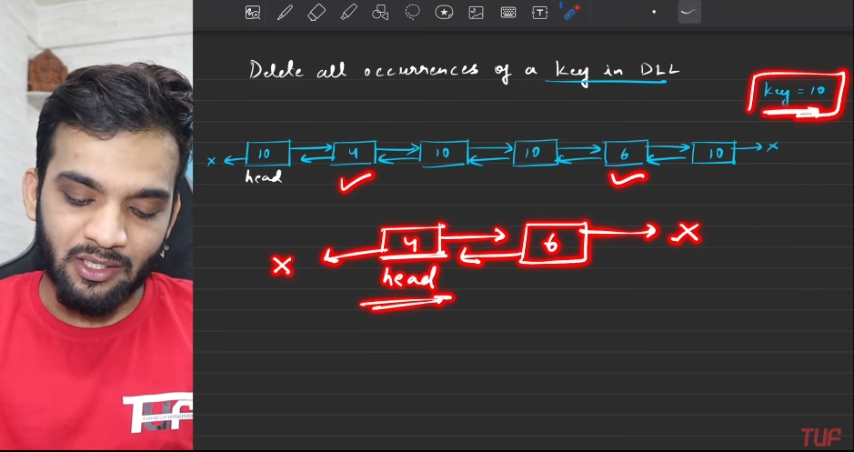
   2. 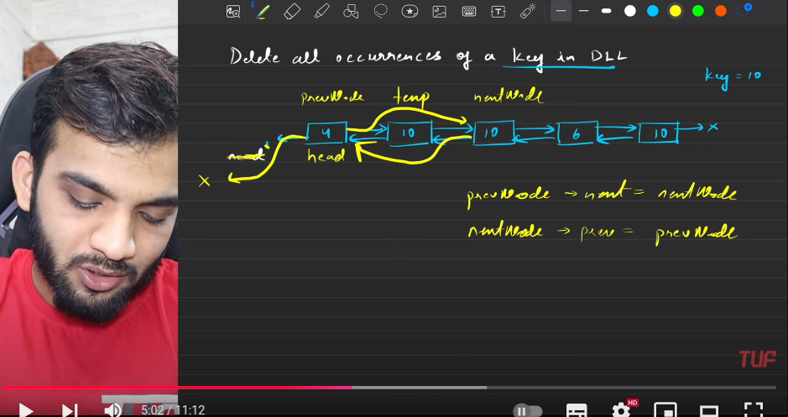
   3. 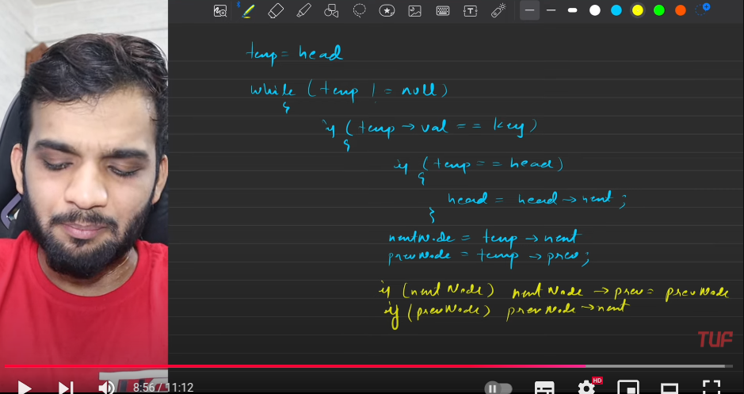
   4. 
   5. 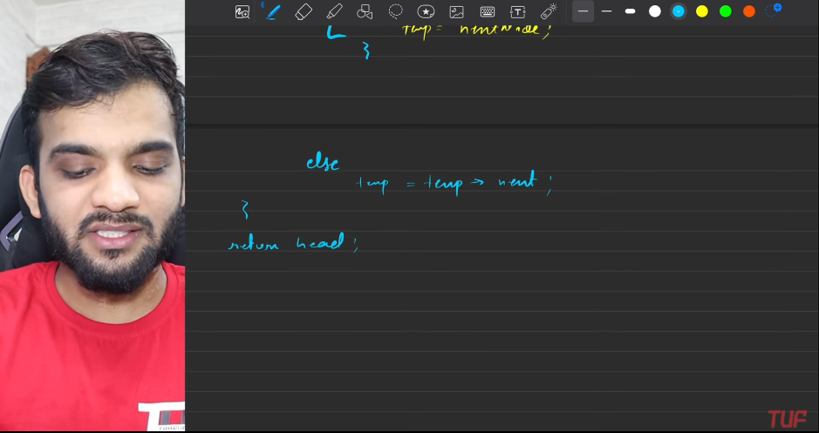
   6. 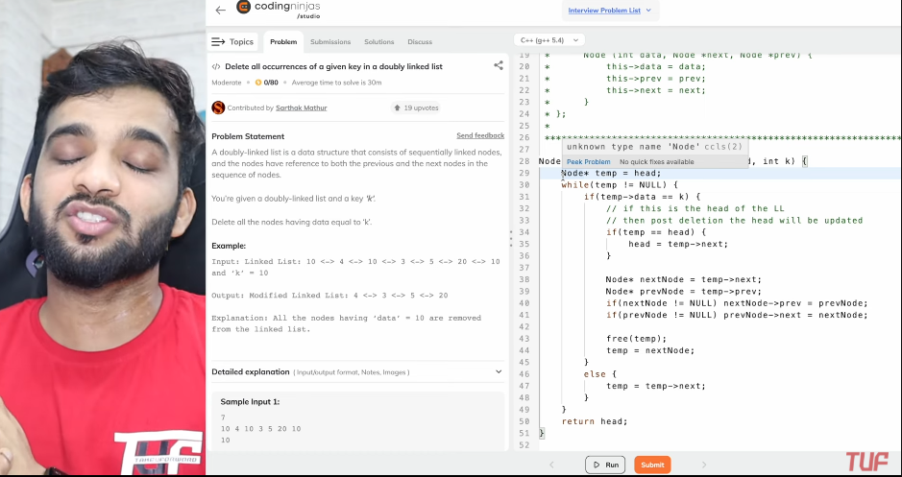
   7. Use the 3 node pointers prev, current, next.

**Find Pairs with given SUM in DLL.**

1. 2 temp, approach.
   1. Given the list are in sorted order.
   2. Keep track of the nodes which gives the sum to be given value.
   3. 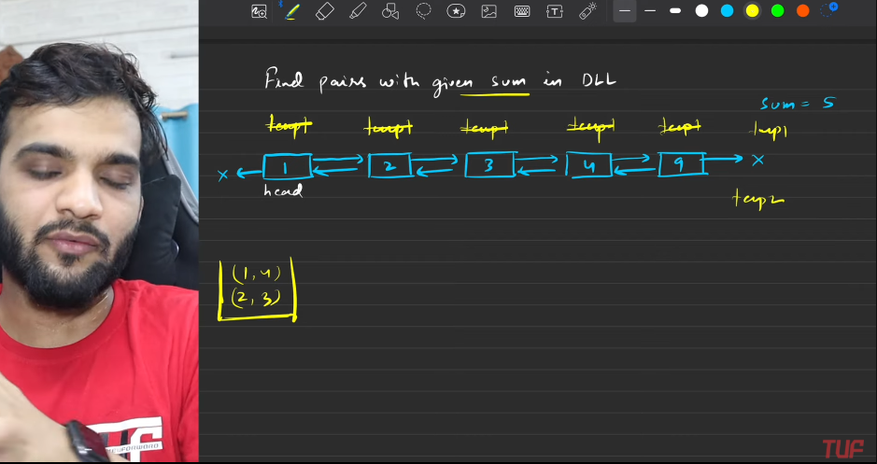
   4. 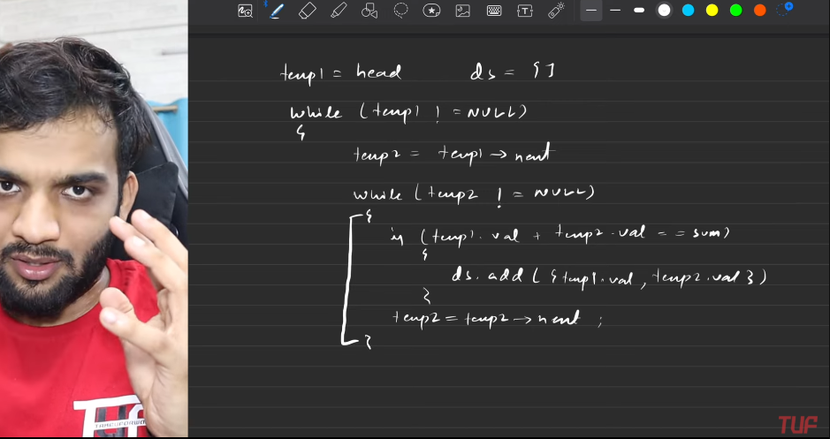
   5. 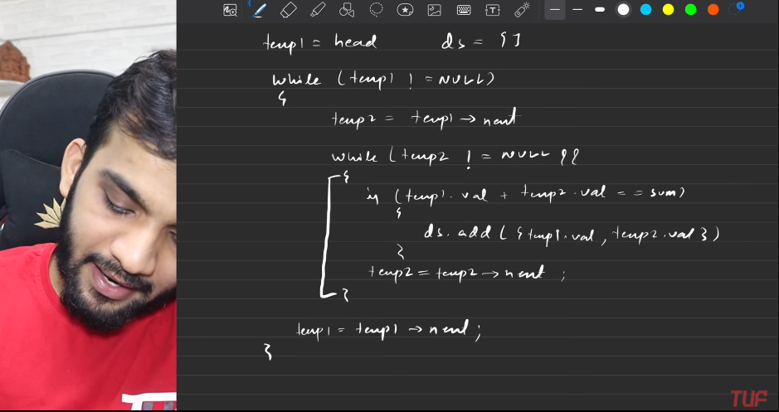
   6. 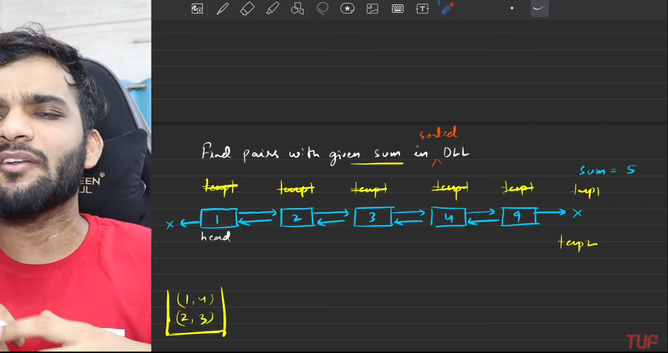
2. **2 pointer approach**
   1. Like arrays. Need to make the arrays.
   2. 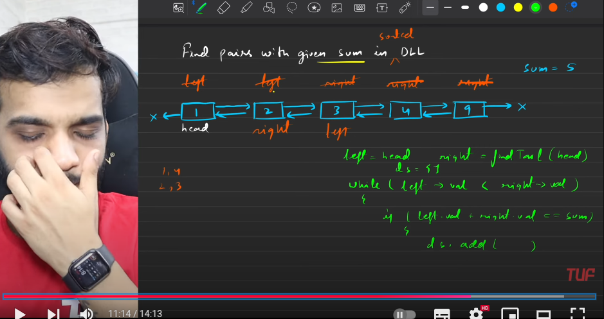
   3. 
   4. 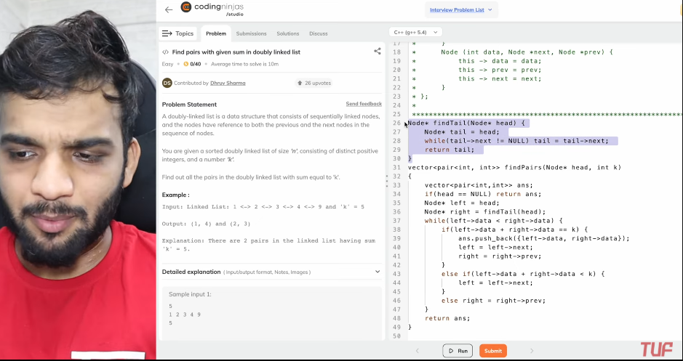
   5. 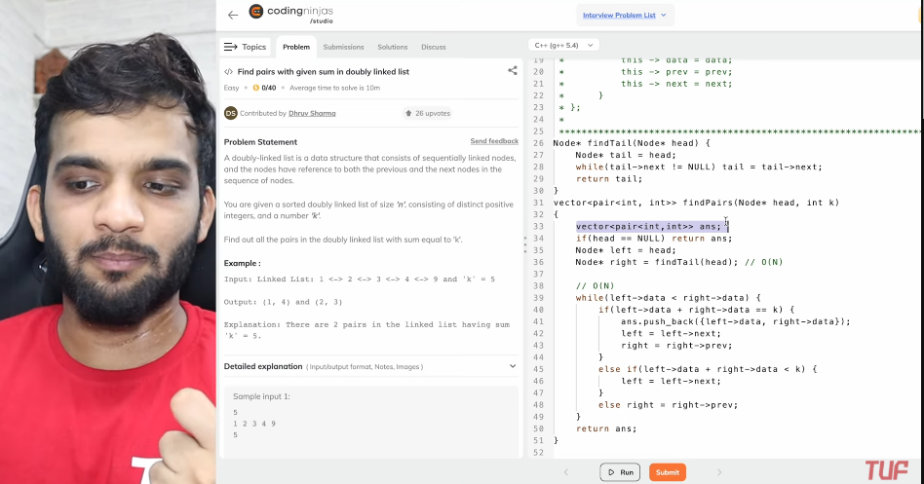

**REMOVE THE DUPLICATES FROM A SORTED DLL**

* 1. 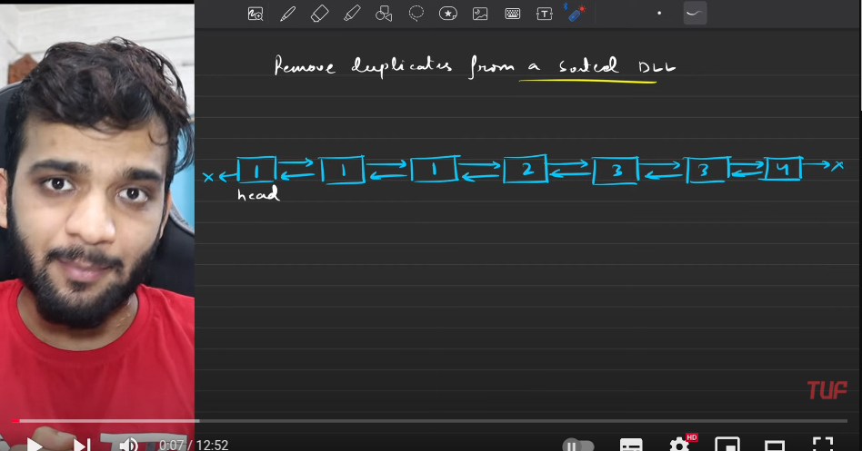
  2. 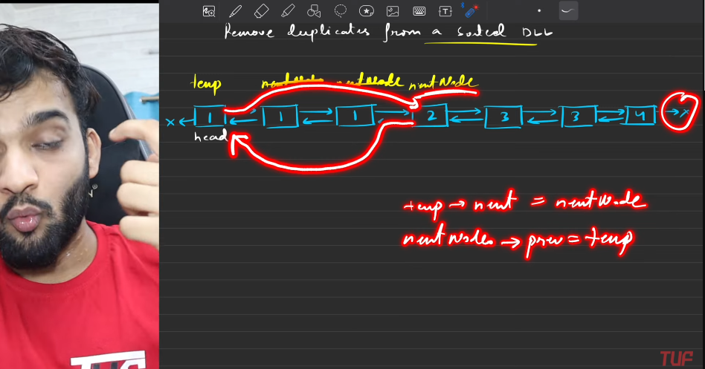
  3. 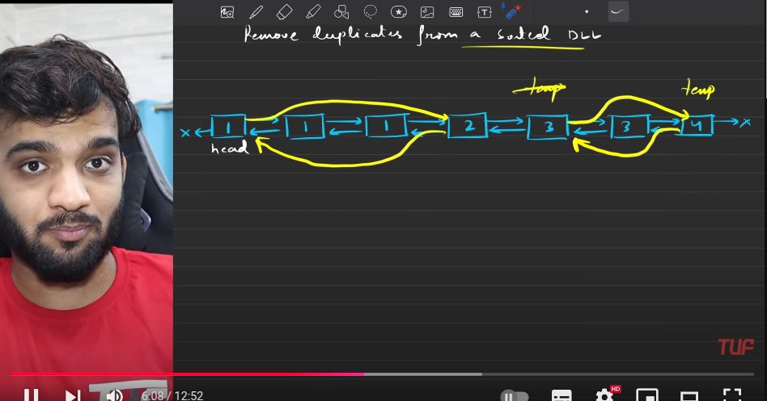
  4. In cpp, you need to code for removal of the nodes.
  5. 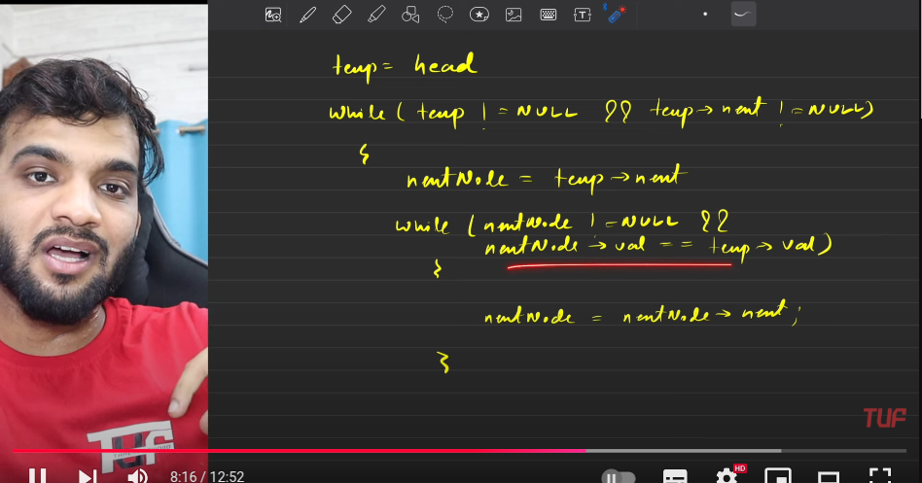
  6. 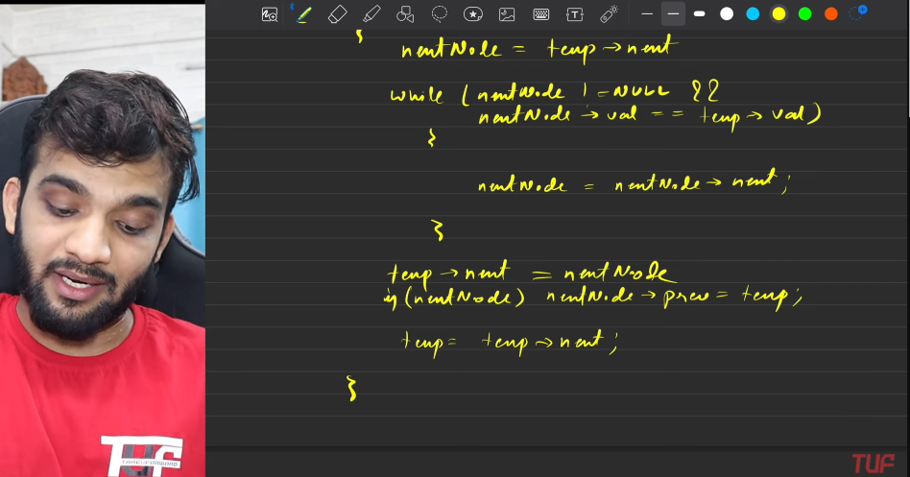
  7. 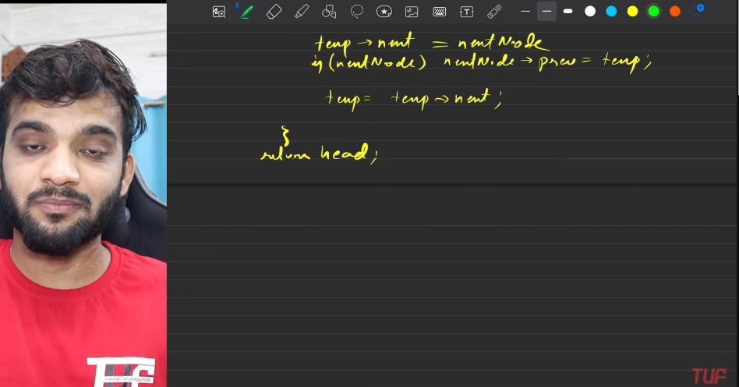
  8. 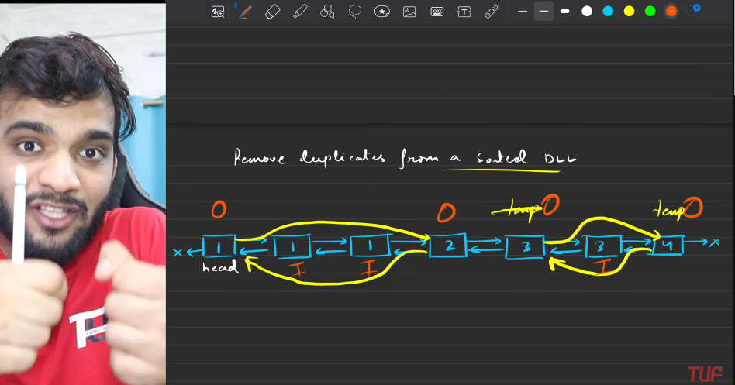
  9. 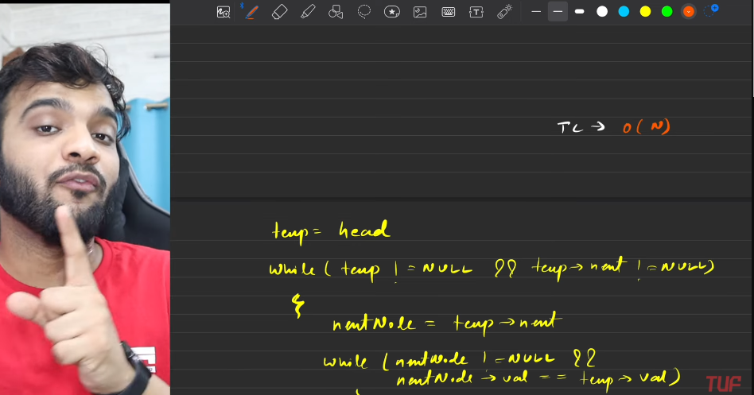
  10. 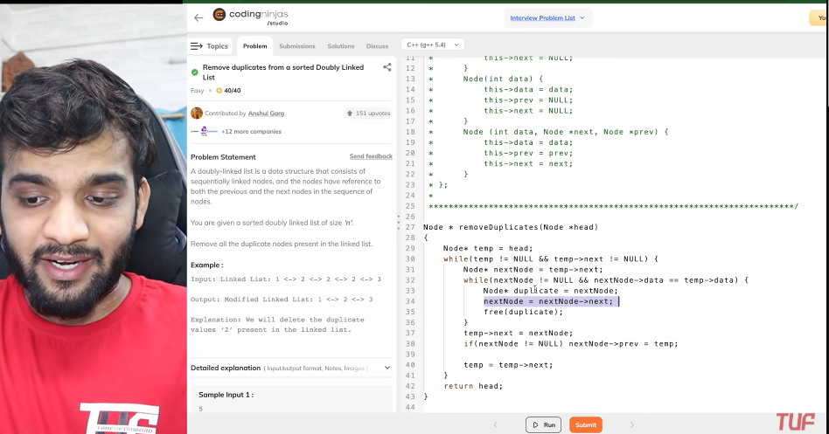
  11. Start with the temp, positioning at the head.
  12. Now start to traverse, when the data at temp and temp->next, both are same, then we need to skip to the place where the data is different.
      1. Use the inner loops in order to make this.
  13. So when the new node with the different data is found, then make the connection of the current with the different data node, hence making the previous connection of the node to the current.
  14. Keep traversing till the temp->next == NULL. make sure first you will be making.

**REVERSING THE NODES IN K GROUPS**

* 1. We can reverse it only if we have the size k, else do not try to reverse.
  2. 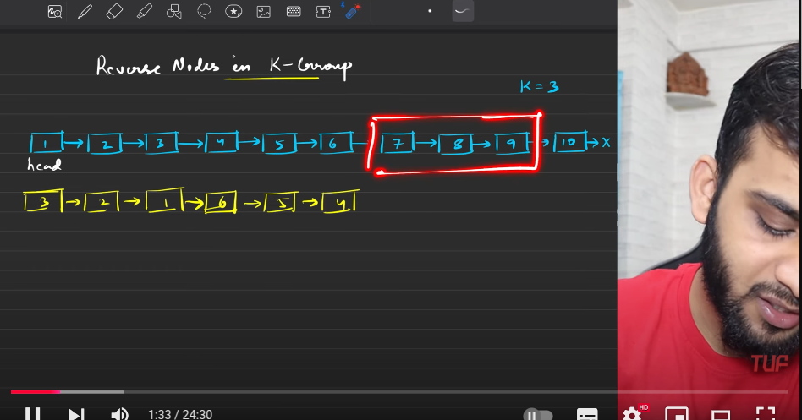
  3. 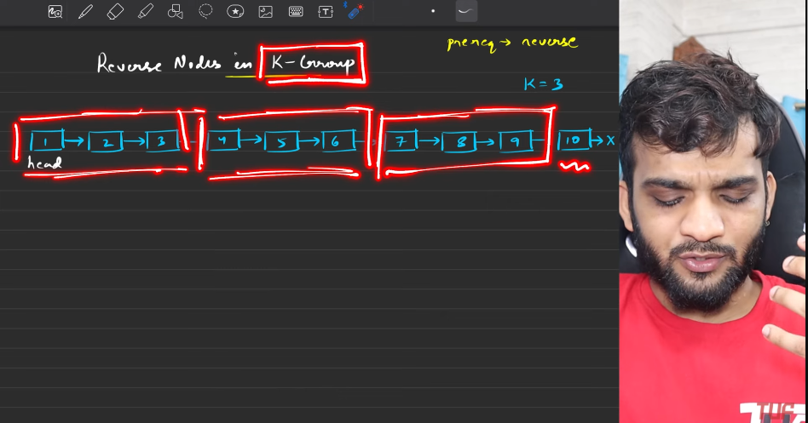
  4. The first thing is that,assign the temp to the hed of linked list, then keep traversing till you make the count==k, initially the k=0, before even starting the traversals.
  5. Reverse function do not take the part of linked list , it takes the total linked list and retunrs the new heas, so need to break the part of linked list and need to get the start as head.
  6. 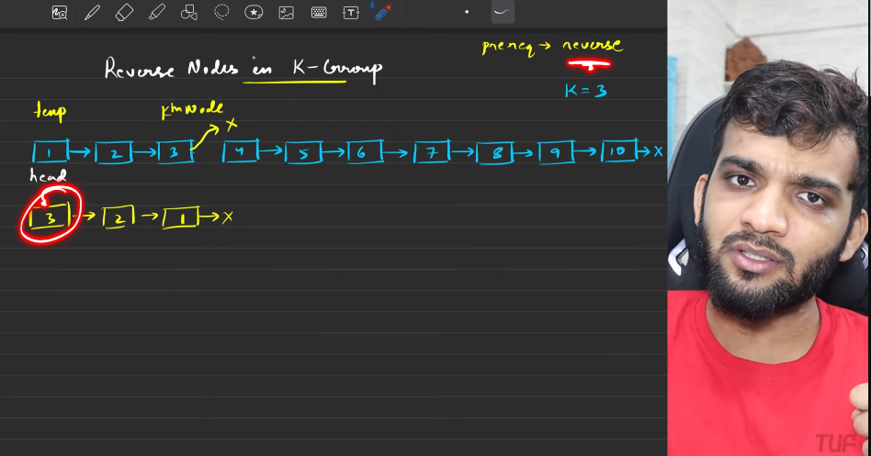
  7. **Update head**
     1. If the temp==head, then make the head to be as the kth node. Remember the kth node will alwasy be the the staart of every partitions.
  8. **Preserve the next node**:
     1. Before breaking the connection from current node, make sure the next of the kth node is noted with some variable, then break the connection between the nodes.
     2. Linking the previous partitions to the next partitions:
        1. 
     3. previous->next = kth node.
     4. When we do not have k elements then no need to reverse.
     5. 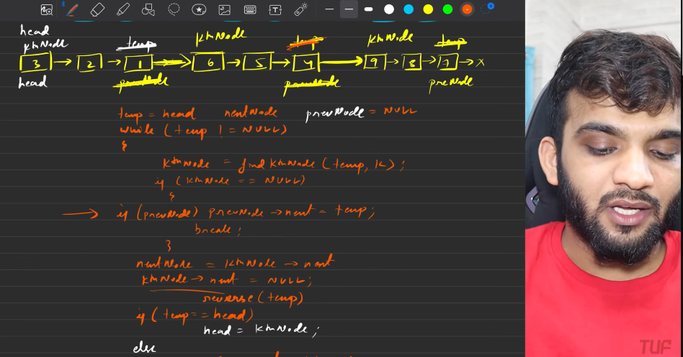
     6. 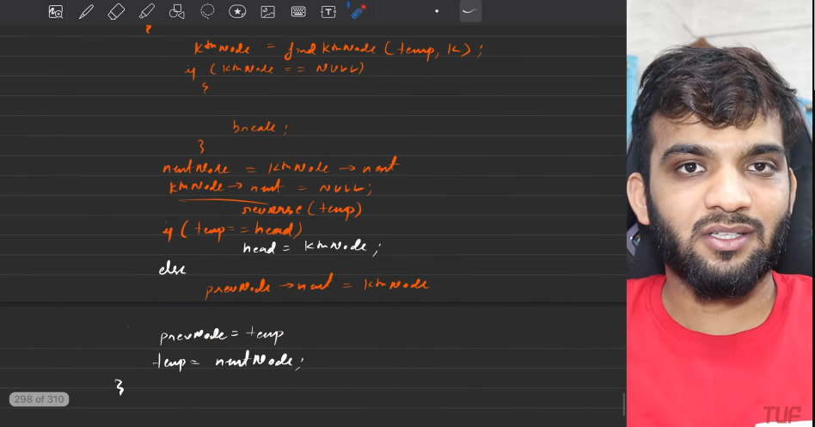
     7. 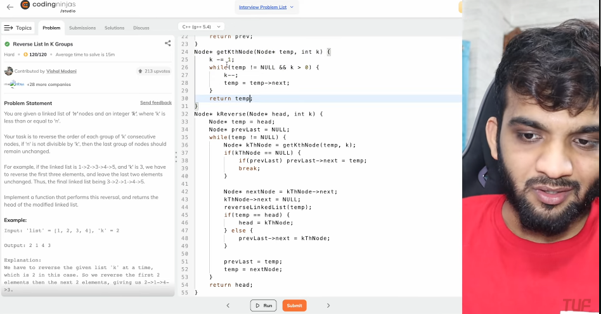
     8. 
     9. Procedure:
        1. Understand; Need to reverse in group of k.
        2. Keep the start as temp,head.
        3. While loop:
           1. If the size of liked list is more than k, we will make the k pointing to the kth distance from teh current.
           2. **else**: if the there is previous node, then previous->next = next_pointer. break then, then return the hdaer
           3. Now point the kth next to be as next.
           4. Break the link from the current(temp) to next.
           5. Give it to reverse, function. So the kth will be the new start. When the head == temp, means we are at the start of the partition, so head = k.
           6. So prev = temp. previous is mainly used in order to link the previous partition to the next partiton.
        4. prev->next = next.
        5. temp = next.
     10. Return the header.
     11. Completed the mission.

1. **Critical points**:
   1. The connection from previous partiton to the current partition.
   2. Deciding the nmber of nodes required.

**ROTATE A LIST BY K TIMES**

1. 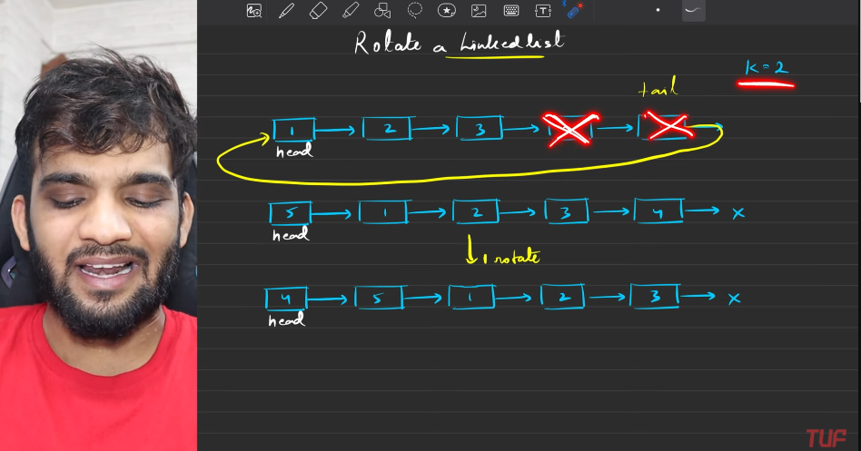
2. 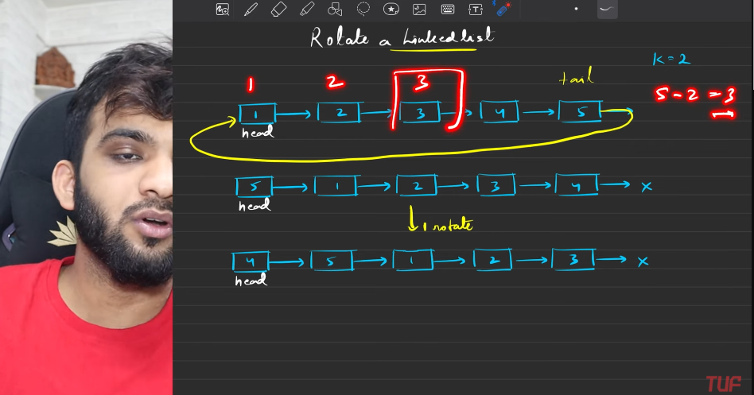
3. 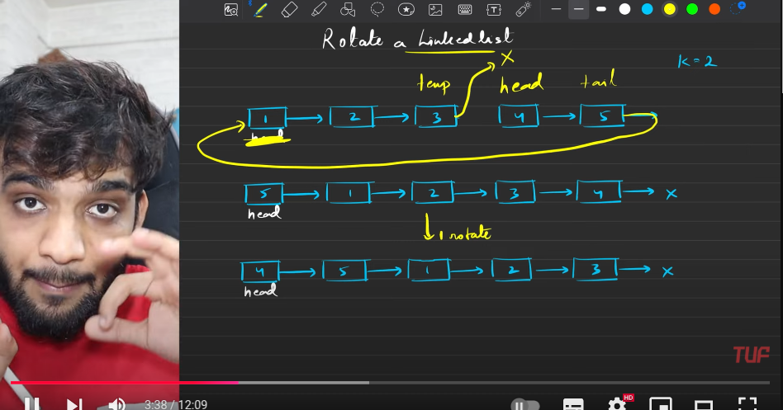
4. 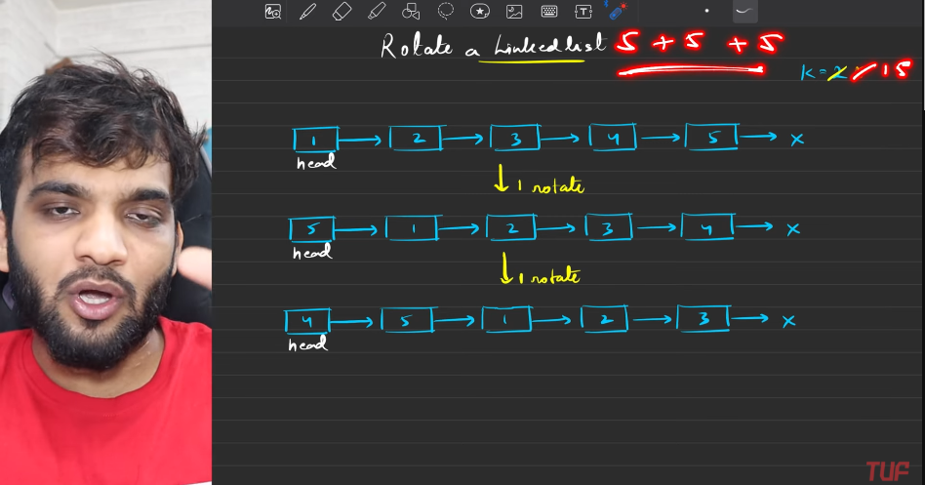
5. 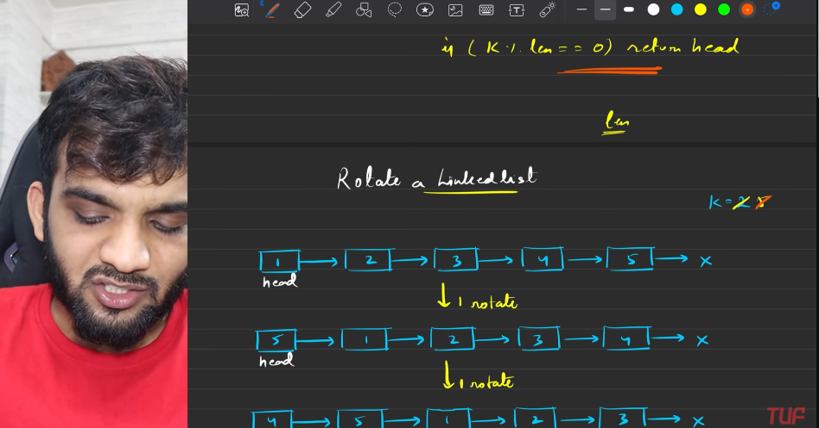
6. 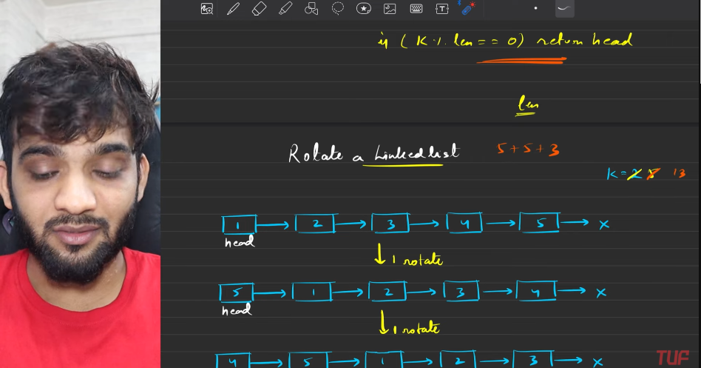
7. 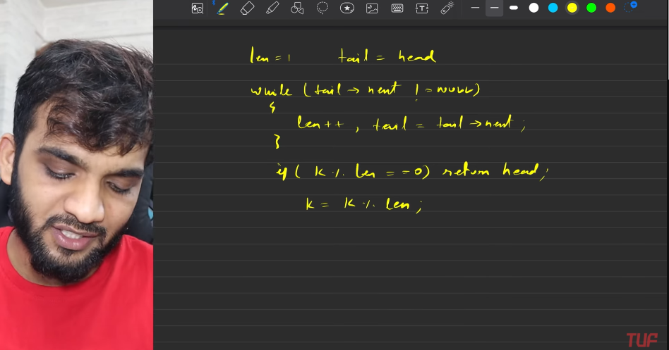
8. 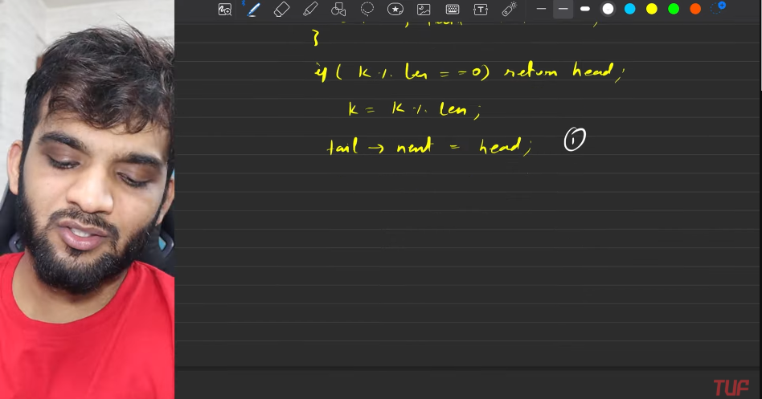
9. 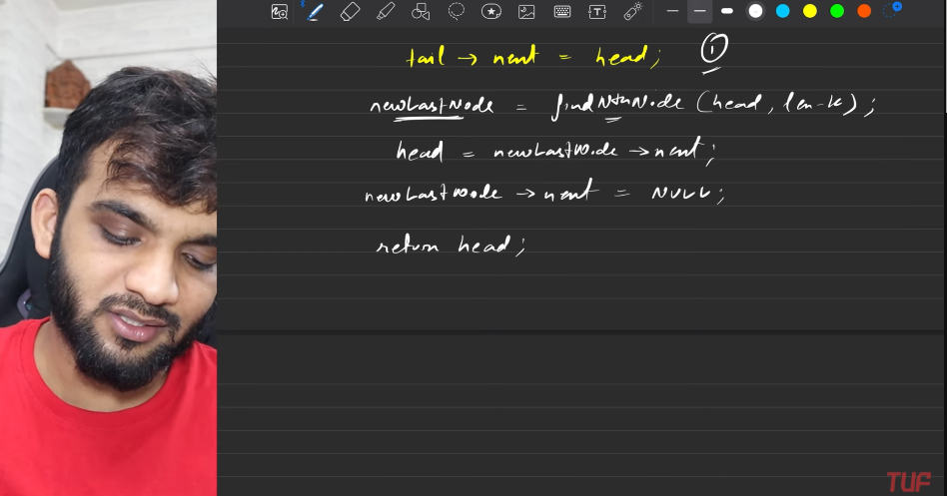
10. 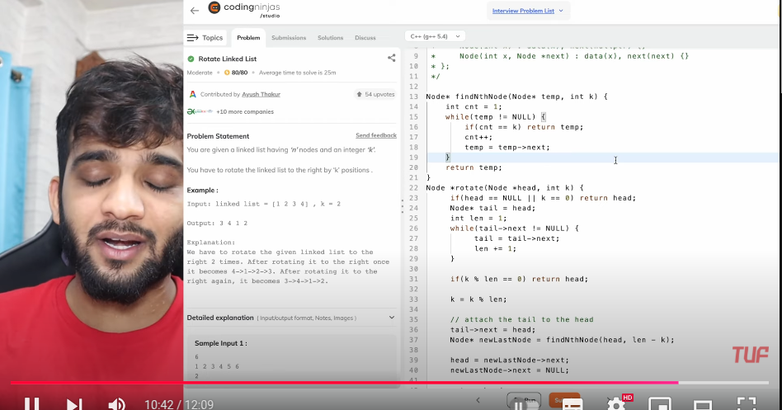

**Flatten a Linked List**

1. 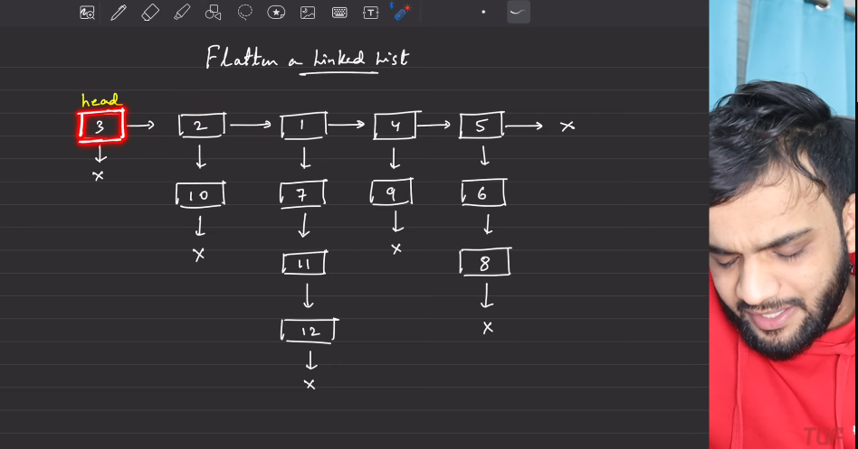
2. It has 2 pointers:
   1. Next pointer.
   2. Child pointers -along the path, all the nodes are sorted. The ones that are mentioned in red border.
   3. head
3. 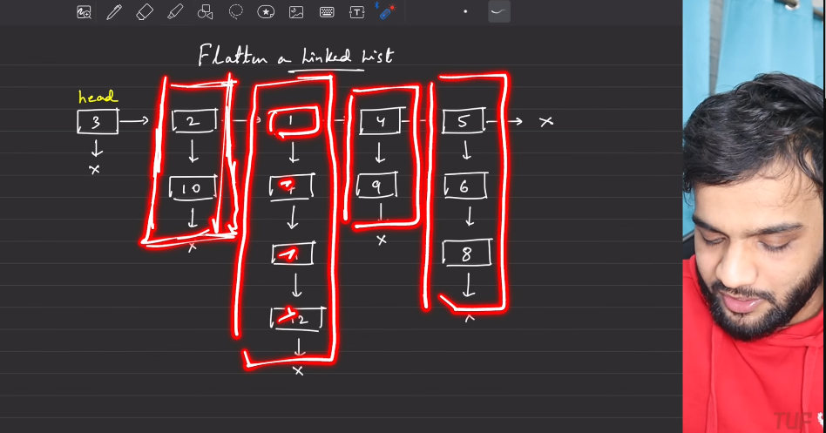
4. Need to return the linked list with the flattenned, sorted, depth order.
5. 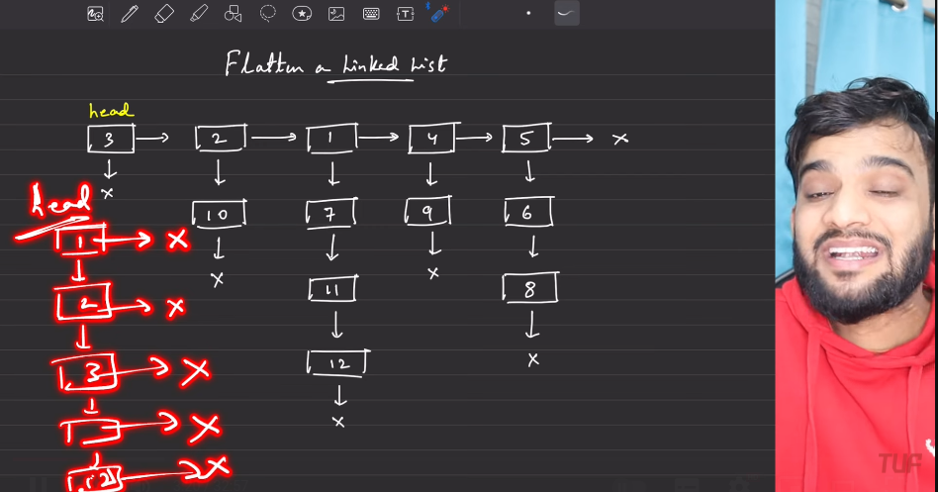
6. Solutions:
   1. **Array**
      1. Start traversing the linked list, in a manner to cover all the nodes in the linked list.
      2. using temp1(head) and temp2(This is use for traversing the depth). Keep uploading all the elments into array.
      3. Sort the array
      4. Create the depth based LL
      5. 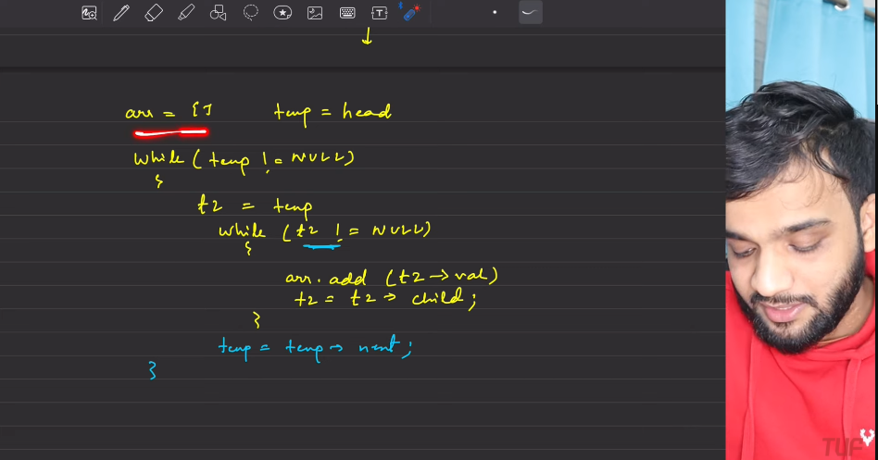
      6. 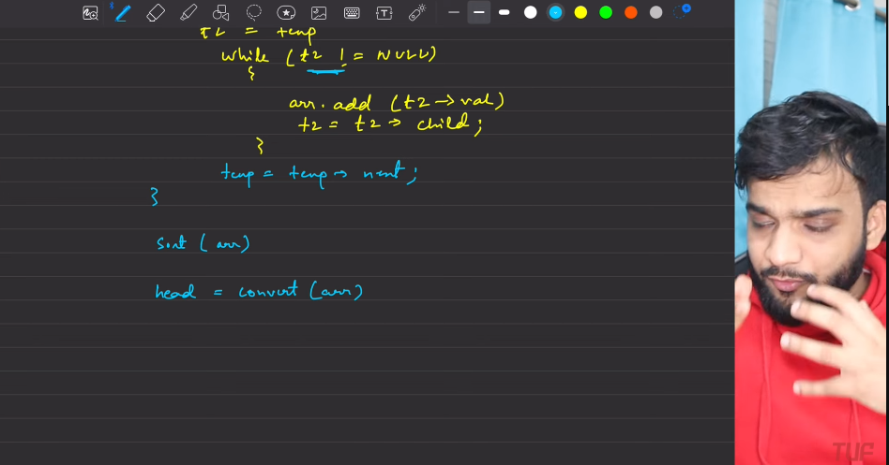
      7. 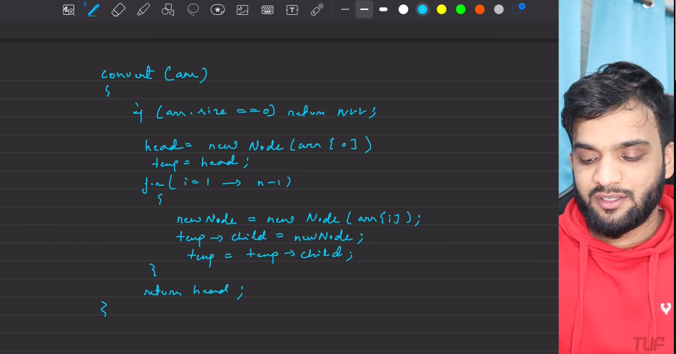
      8. 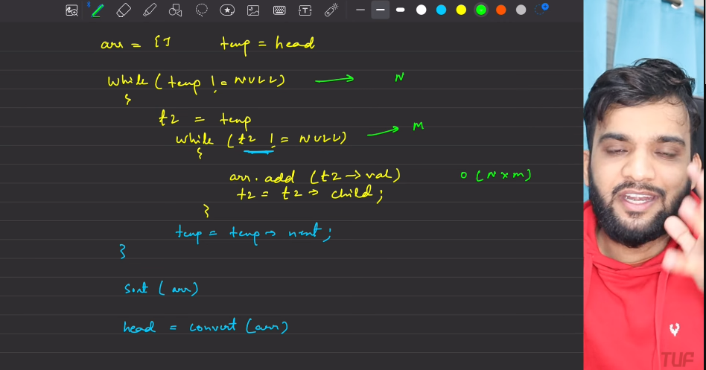
      9. 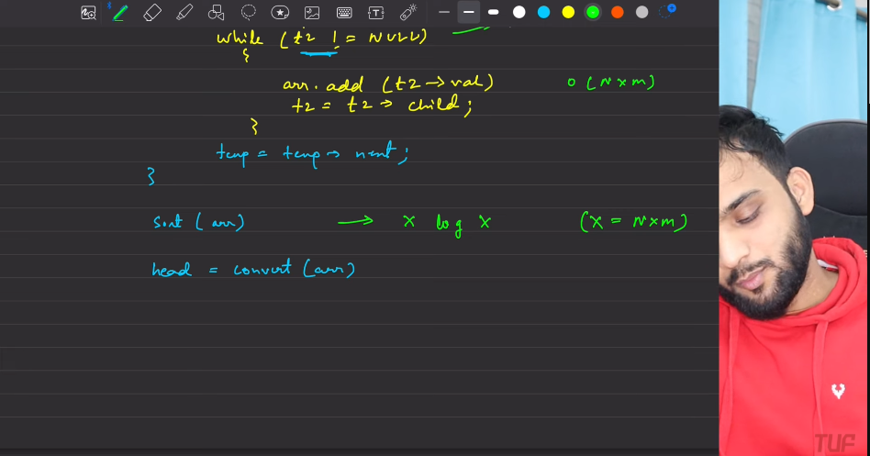
      10. 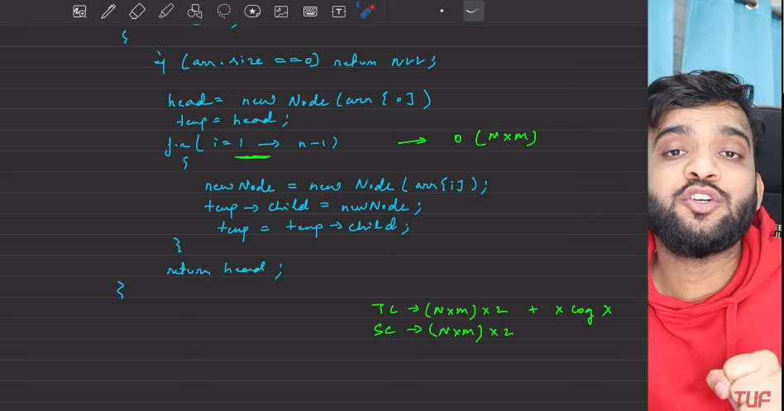
   2. Optimal solution:
      1. Property: The vertical list is sorted. Re use the same nodes, instead of creating new linked list.
      2. 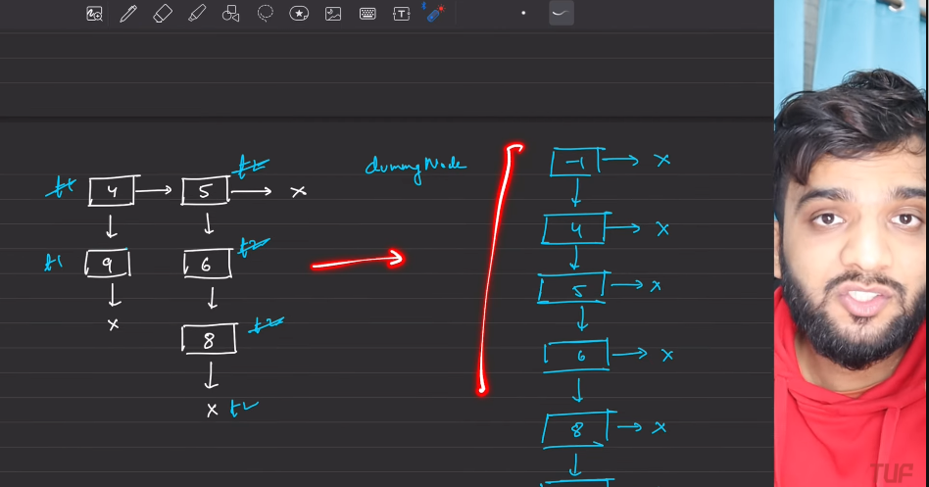
      3. Using merge the 2 sorted list.
         1. 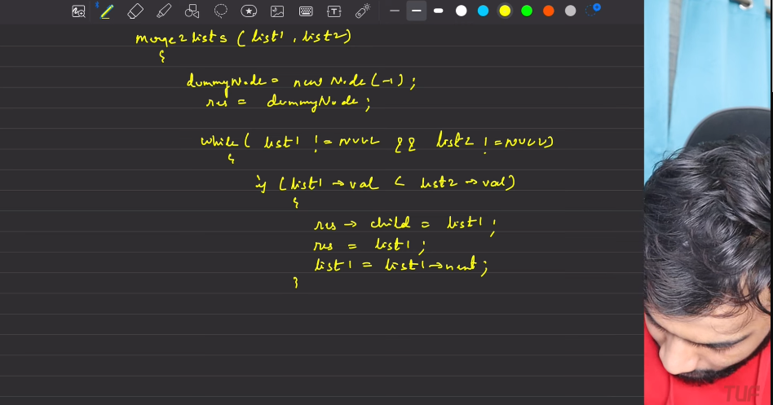
         2. 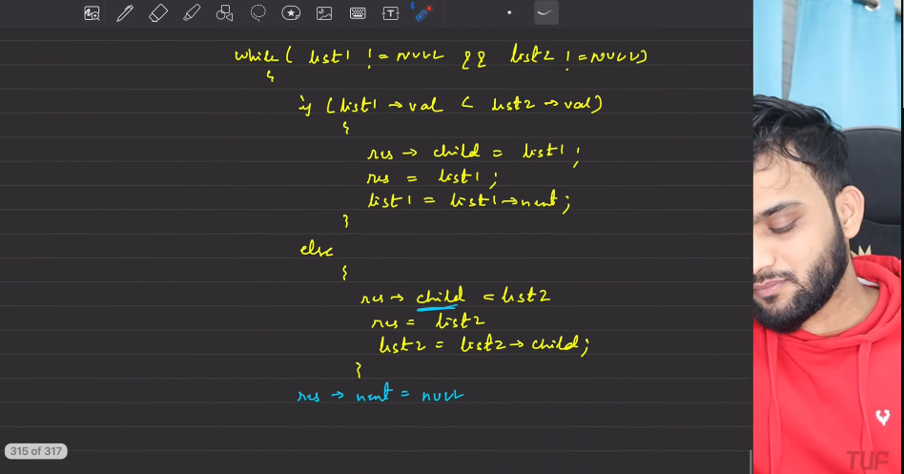
         3. 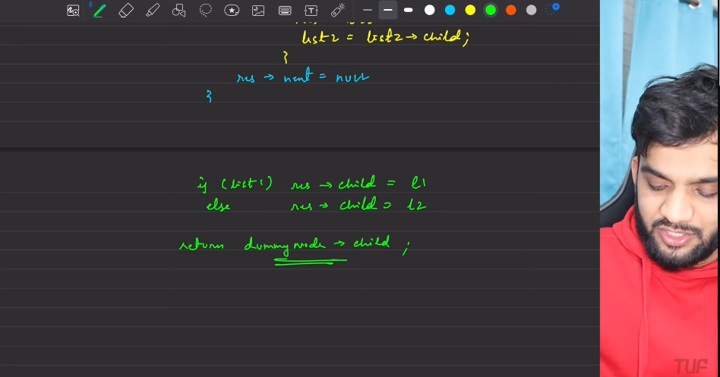
         4. 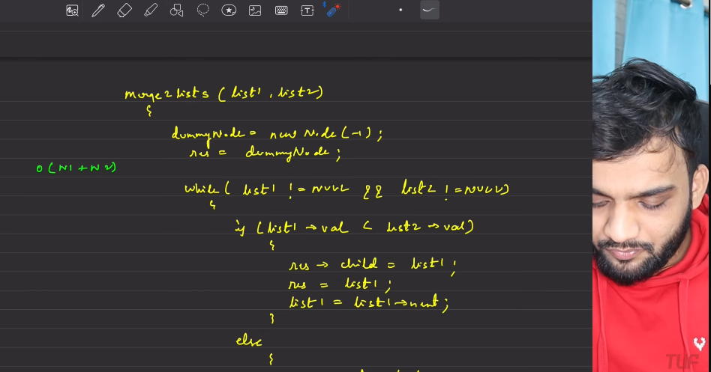
         5. 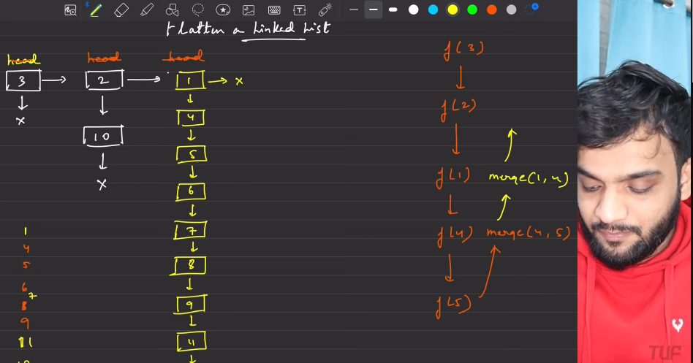
         6. 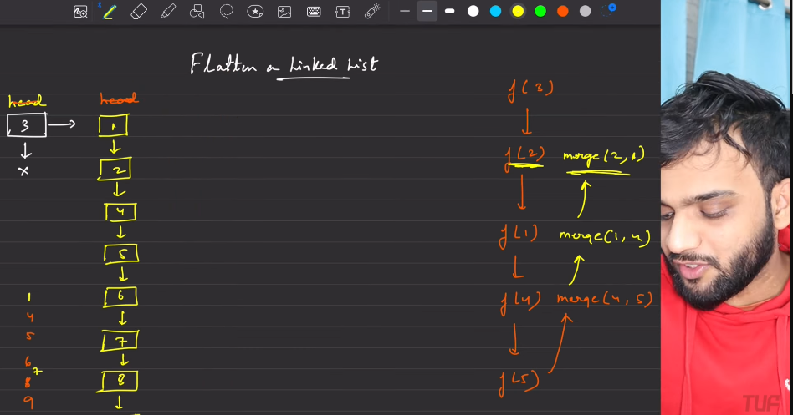
         7. 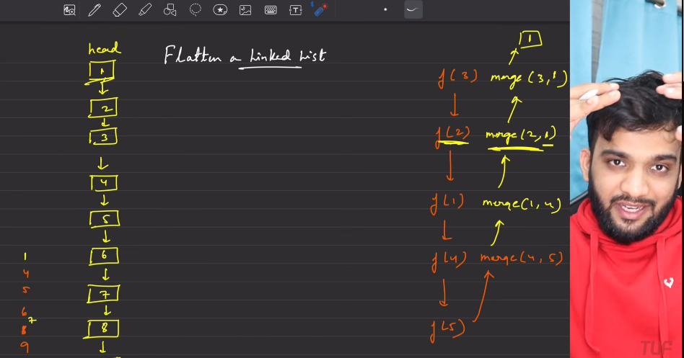
         8. 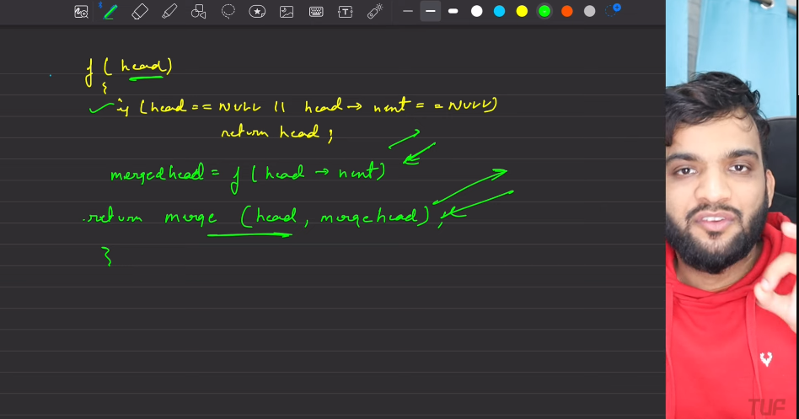
      4. 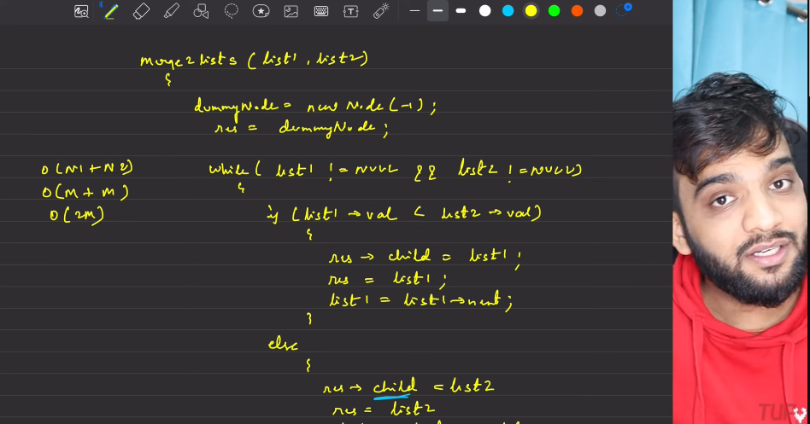
      5. 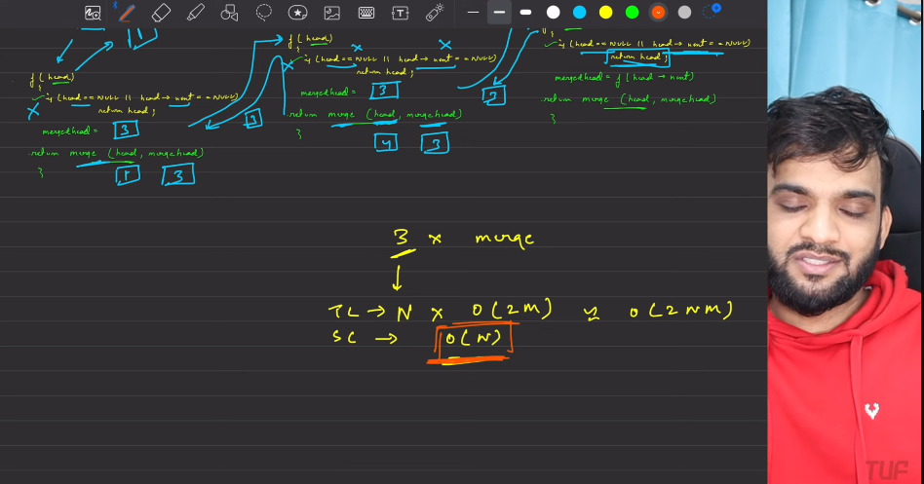
      6. 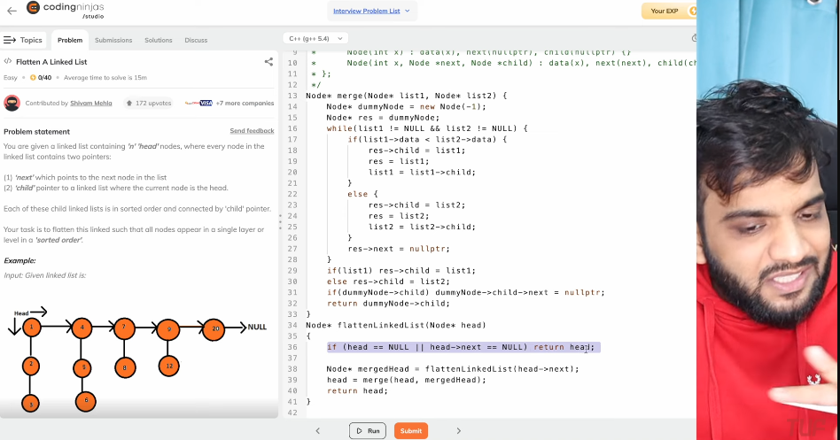

**Clone a linked list with Nxt and Random Pointers**

1. 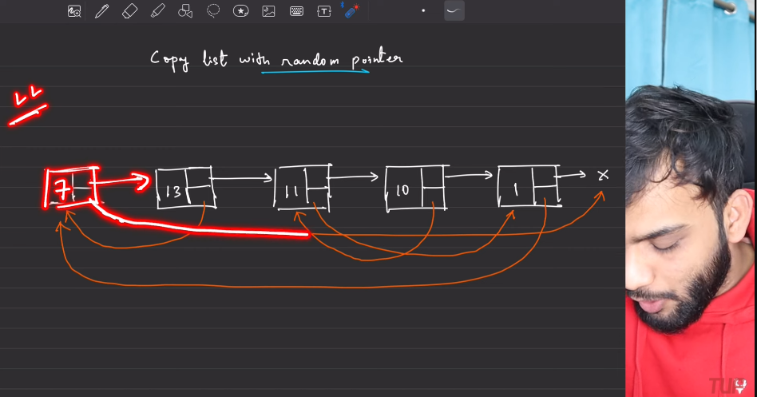
   1. Remember: When you are making the new list, first start with the dummy node, being -1.
   2. You will be given the linked list, we need to replicate the linked list like the same.
      1. **Procedure(me)**:
         1. FIrst create a list with all the nodes which are associated with next.Whole list is made.
         2. The once again start to traverse the nodes, by making the random connection.
         3. this should be done with the help of the map function.
      2. Copy nodes in between the nodes.
2. 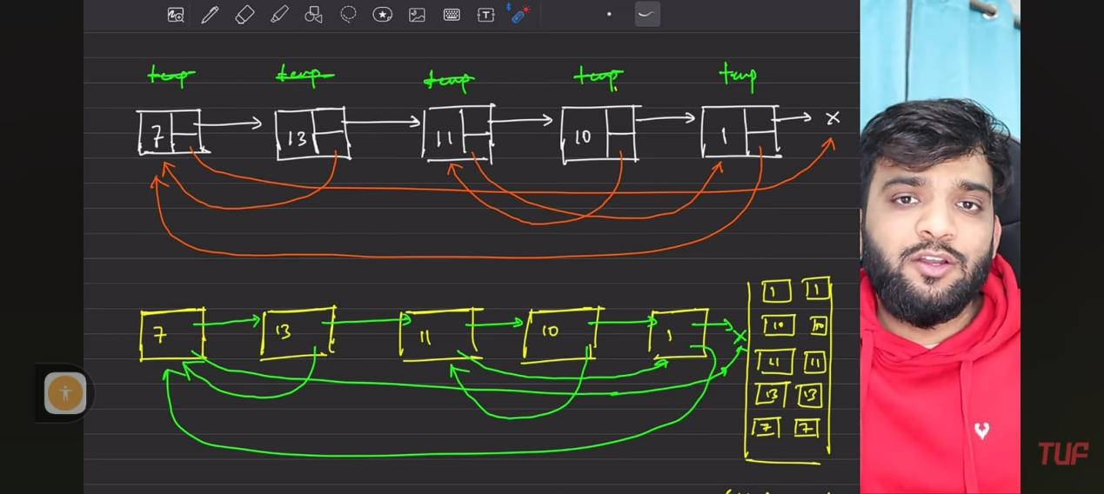
3. 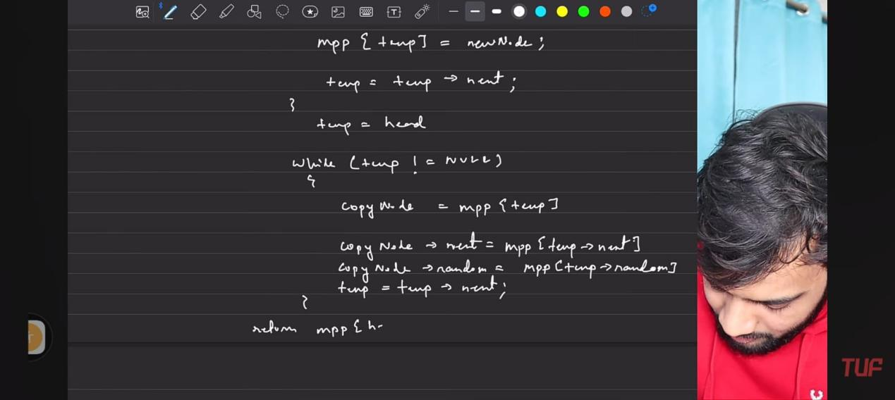
4. 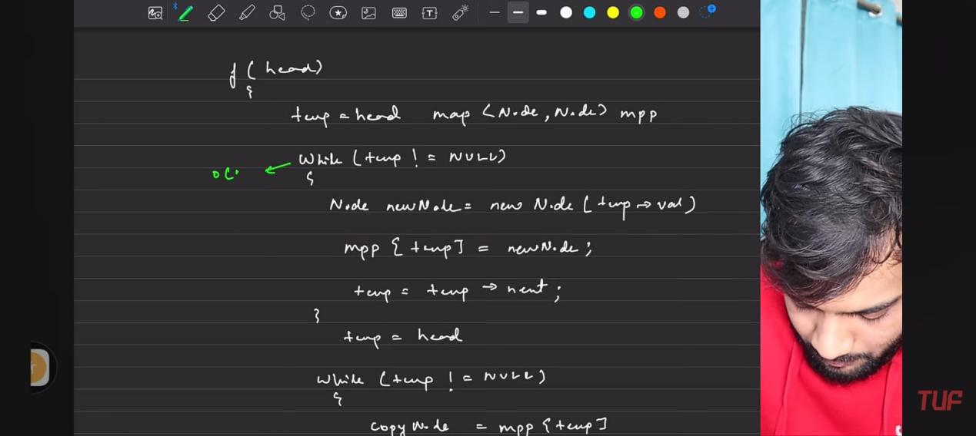
5. 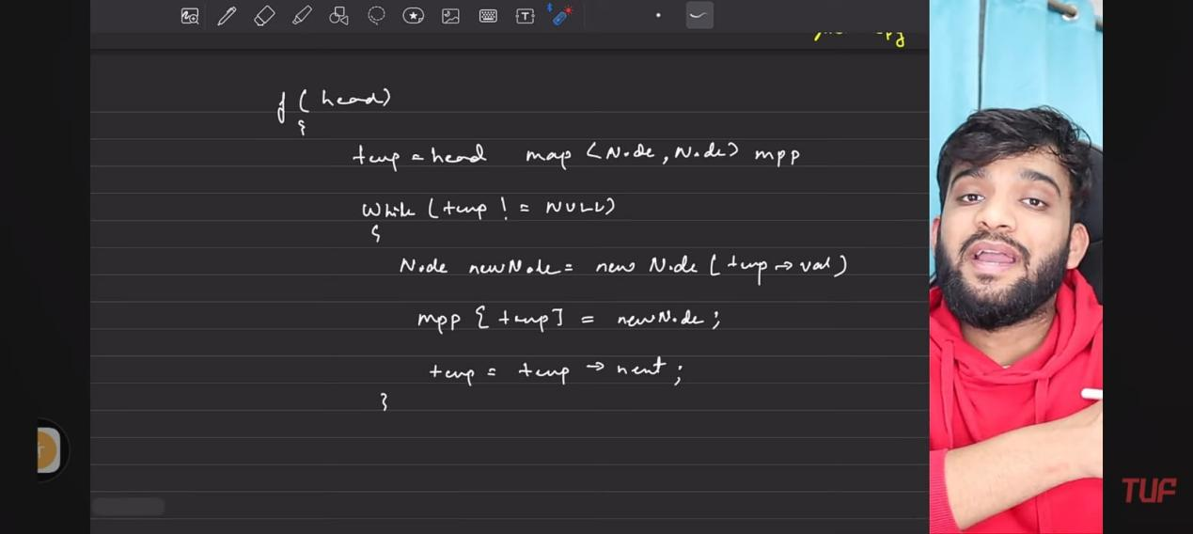
6. 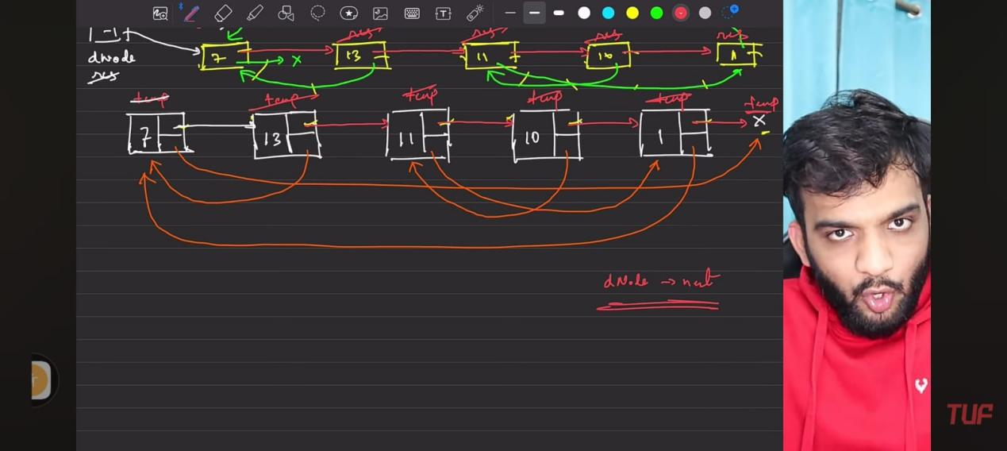
7. 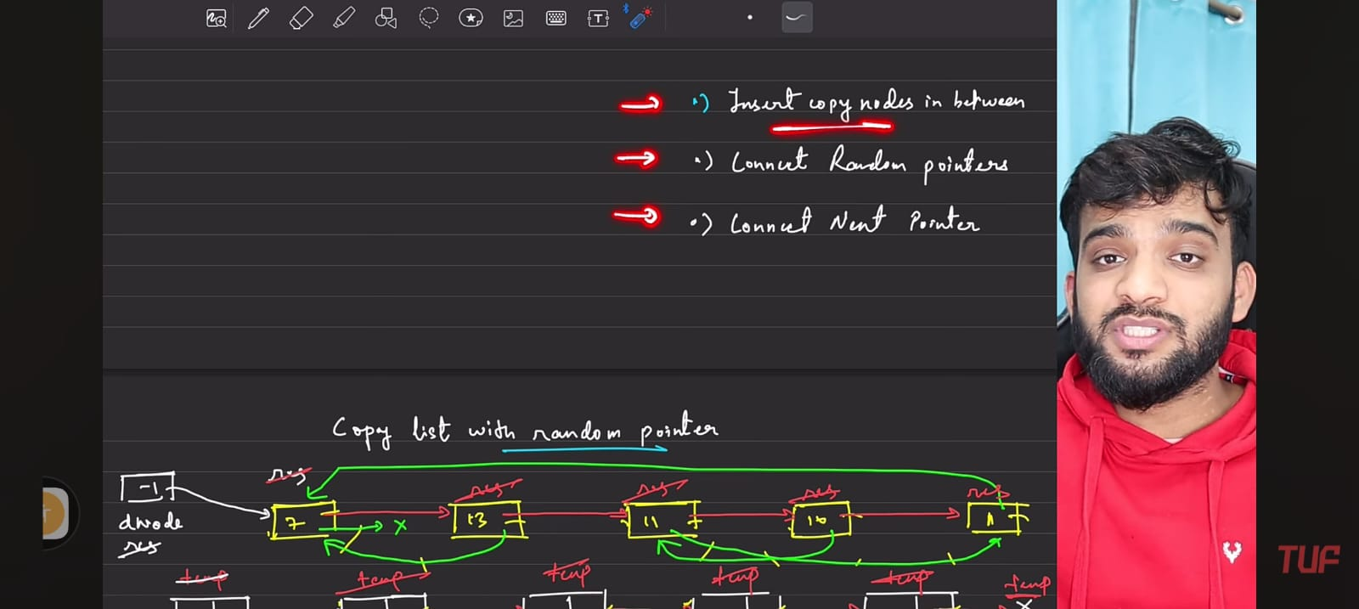
8. 
9. 
10. 
11. 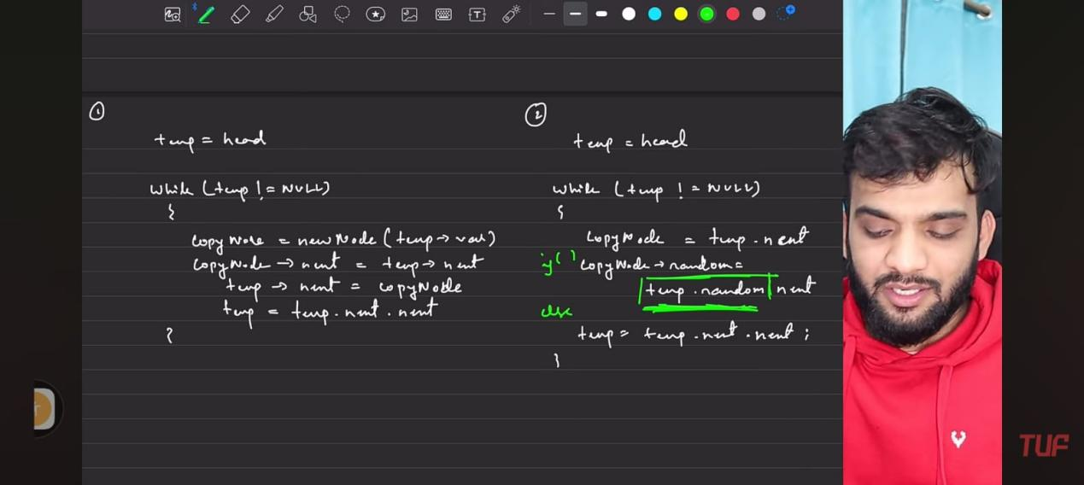
12. 
13. 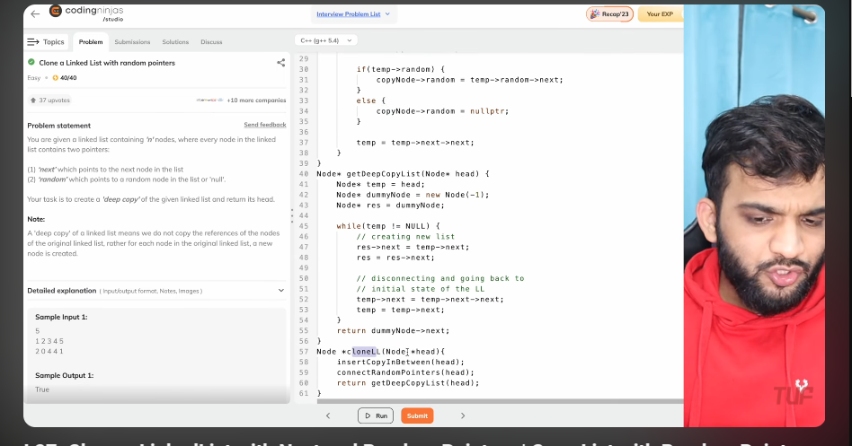
14. 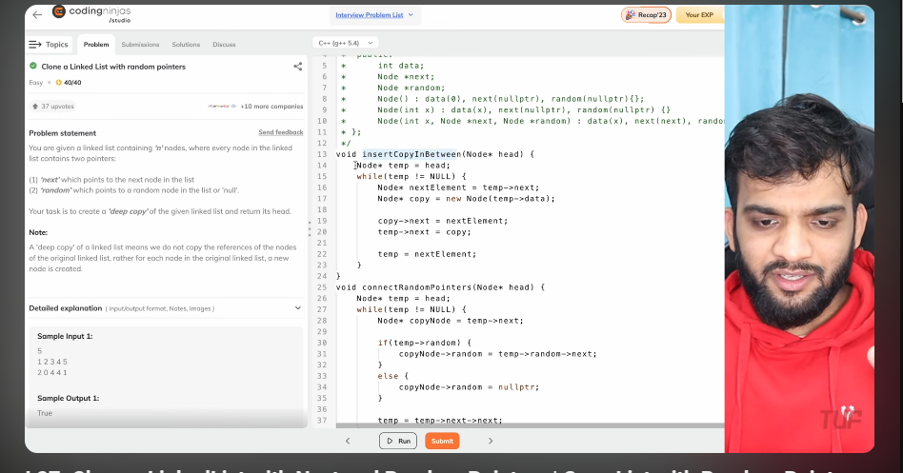
15. 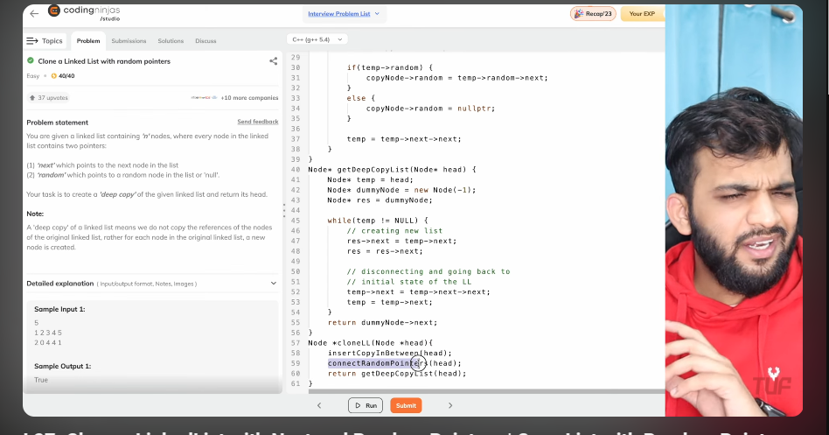
16. 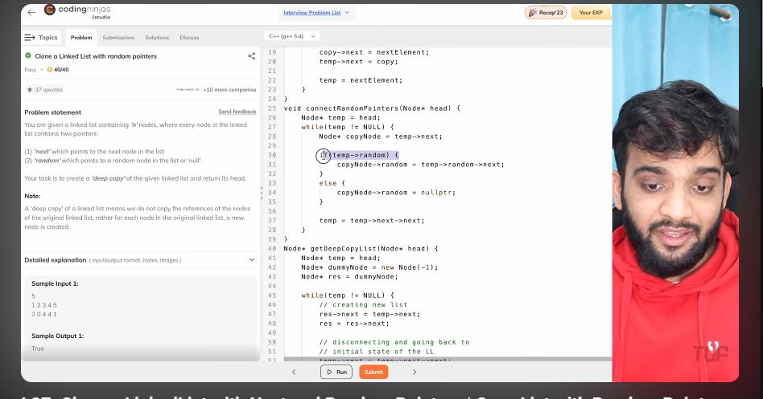
17. 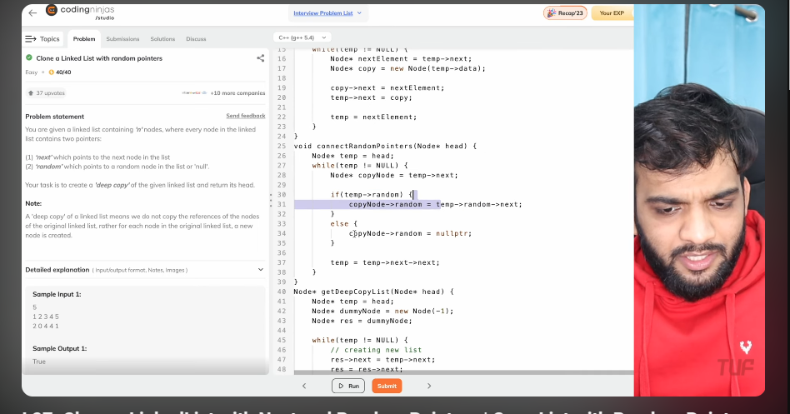
18. 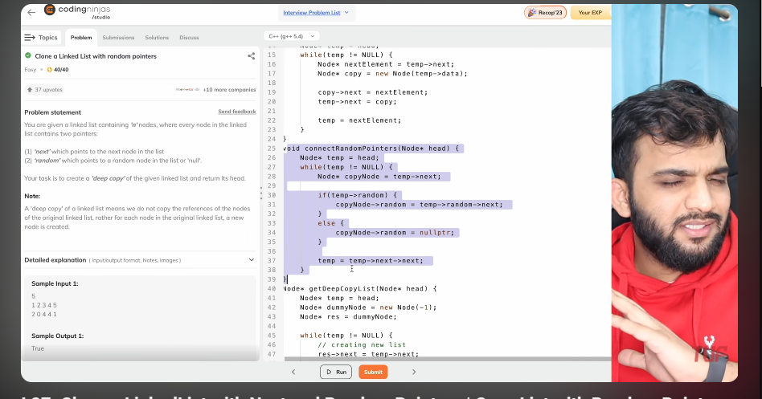
19. 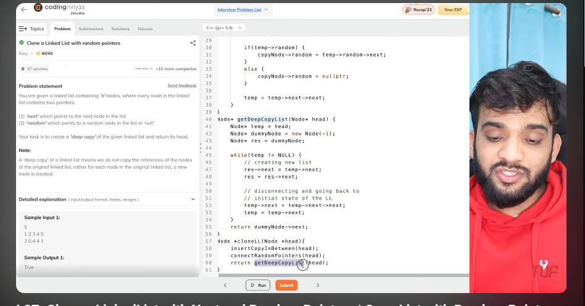
20. 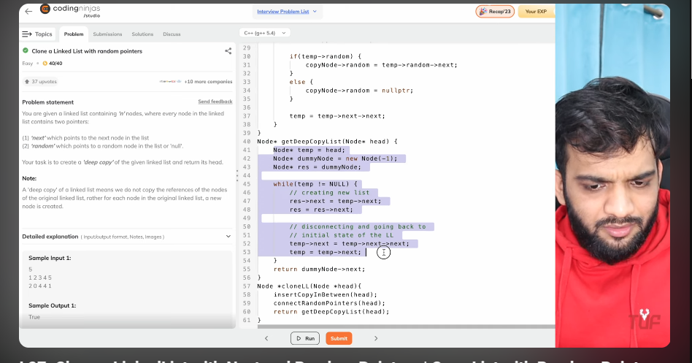
21. 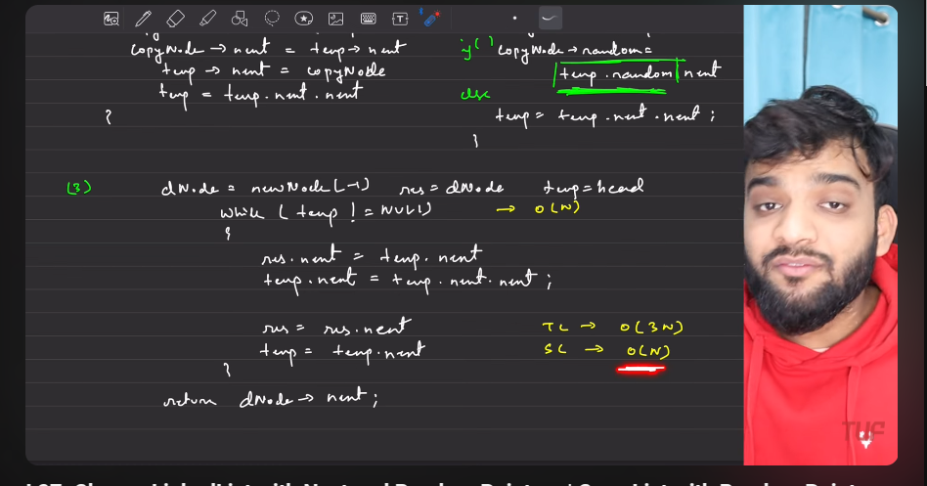
22. s